Output Buffering

Definition:
# Source: AI Source: Provided by: [Data Path: Persons Table -> ID Column: 1, Name_En Column: Motasem Essam] -> From: [Chatgpt (GPT‑5 Mini)] on [12/10/2025]
Output buffering is a technique where data to be sent to an output device (like a screen, printer, or file) is first stored in a buffer in memory before being written to the device. This helps improve efficiency and speed, especially when the output device is slower than the CPU.

How It Works
# Source: AI Source: Provided by: [Data Path: Persons Table -> ID Column: 1, Name_En Column: Motasem Essam] -> From: [Chatgpt (GPT‑5 Mini)] on [12/10/2025]
- The program generates data to output.
- Instead of sending each byte/record immediately to the output device, the data is stored in an output buffer.
- Once the buffer is full or the program is finished, the data is sent to the device in a single block.

Advantages of Output Buffering
# Source: AI Source: Provided by: [Data Path: Persons Table -> ID Column: 1, Name_En Column: Motasem Essam] -> From: [Chatgpt (GPT‑5 Mini)] on [12/10/2025]
- Faster execution: Reduces the number of write operations to slow devices.
- Efficient resource use: CPU can continue processing while data is temporarily stored in memory.
- Smooth output: Helps prevent flickering on screens or slow printing.

Example
# Source: AI Source: Provided by: [Data Path: Persons Table -> ID Column: 1, Name_En Column: Motasem Essam] -> From: [Chatgpt (GPT‑5 Mini)] on [12/10/2025]
- Writing to a file in Python:
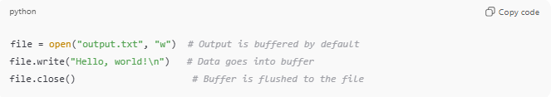
file = open("output.txt", "w") # Output is buffered by default
file.write("Hello, world!\n") # Data goes into buffer
file.close() # Buffer is flushed to the file
- Here, the program writes to the buffer first, then the buffer content is sent to the file when it’s full or when the file is closed.

Analogy
# Source: AI Source: Provided by: [Data Path: Persons Table -> ID Column: 1, Name_En Column: Motasem Essam] -> From: [Chatgpt (GPT‑5 Mini)] on [12/10/2025]
- Program → Chef cooking meals
- Buffer → Tray holding finished meals
- Output device → Customers at the table
- The chef places meals on the tray (buffer) → Customers get meals in batches → faster and smoother service.

✅ Summary:
# Source: AI Source: Provided by: [Data Path: Persons Table -> ID Column: 1, Name_En Column: Motasem Essam] -> From: [Chatgpt (GPT‑5 Mini)] on [12/10/2025]
- Input buffering: Stores data coming into the program.
- Output buffering: Stores data going out of the program.
- Both types reduce the wait time caused by slow devices and increase efficiency.

